
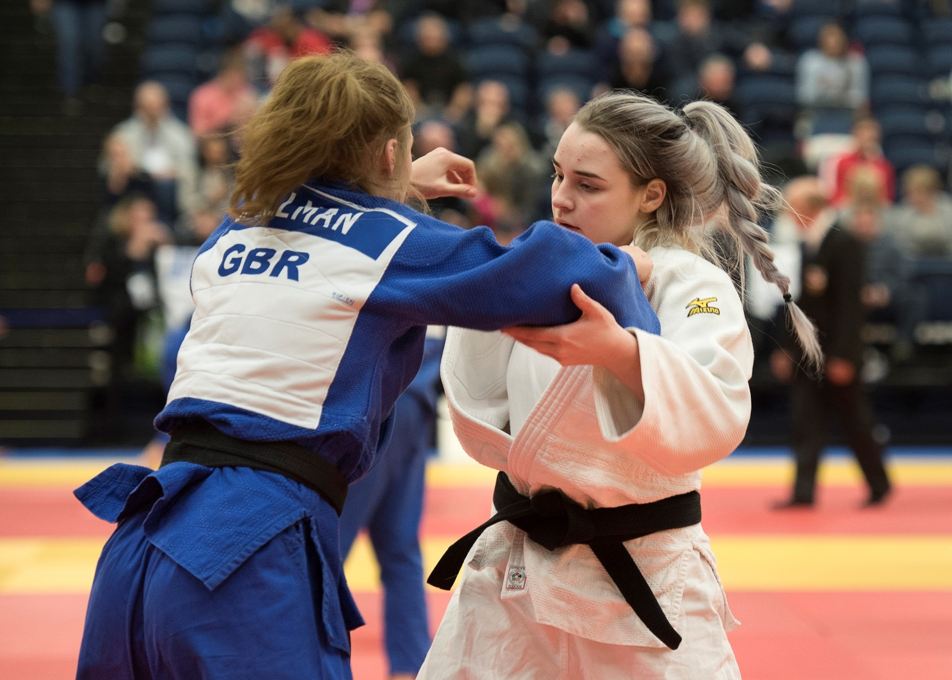
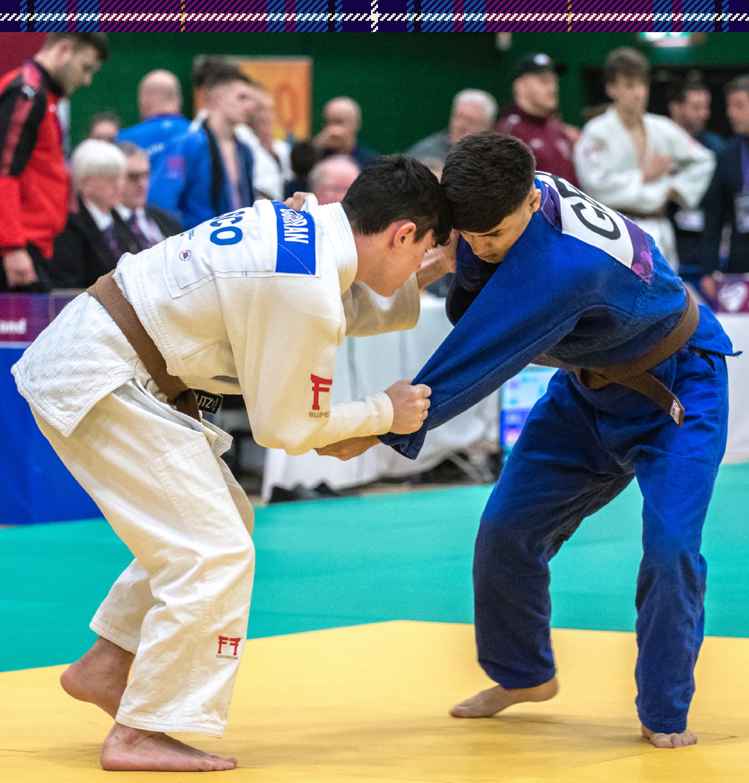
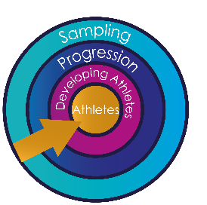
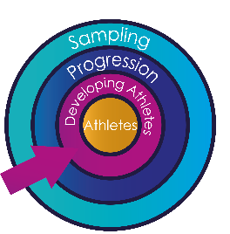
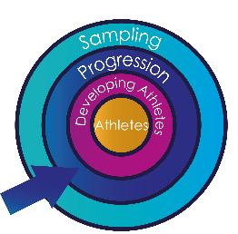
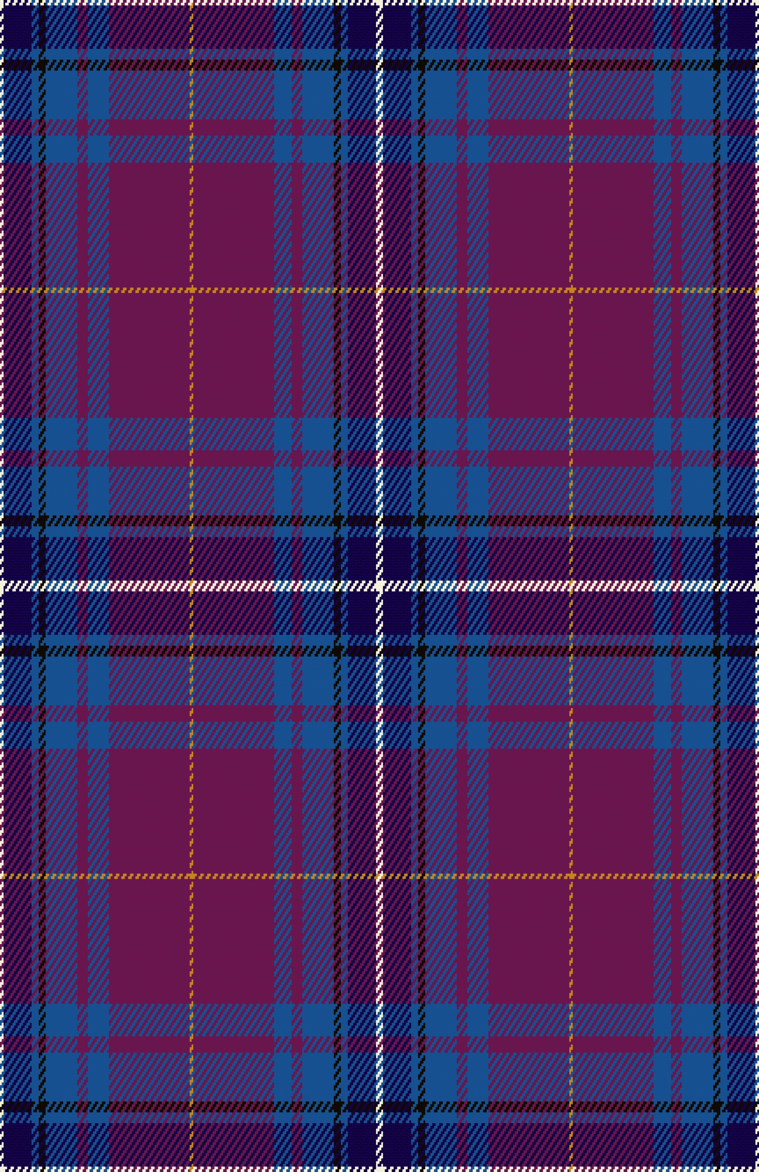
Organiser
The Scottish National Closed Championship is intended to provide judoka with an appropriate level of competition. This event is suitable for those that are at the progression (minors and pre-cadets), developing athletes (cadets & seniors) and athletes stage (seniors) within the JudoScotland Player Development Framework. Please speak to your club coach before entering to ensure this event is suitable for you.
The Scottish National Closed Championship 2024
Ravenscraig Regional Sports Facility, 1 O’Donnell Way, Motherwell, ML1 2TZ
Saturday 9th November 2024

- JudoScotland
Contact Details
- Address: JudoScotland, EICA Ratho, South Platt Hill, Ratho, Newbridge, EH28 8AA.
- Email: events@judoscotland.com.
- Telephone: 0131 333 2981 (JudoScotland Office.)
- Emergency Contact: 07543 287 451 (Jo Imrie.)
Venue
- Ravenscraig Regional Sports Facility, 1 O’Donnell Way, Motherwell, ML1 2TZ
Dates
- Competition date:
- Saturday 9th November
- Closing date: All entries and payment must be received by 1200 hours on Wednesday 23rd October 2024.
- JudoScotland reserve the right to close the entry prior to the published closing date if the maximum entry number has been reached.
- Event T-shirt orders must be received by 1200 hours on Wednesday 23rd October 2024.
Entry Fee
- Single entry fee. £30.00 - Entry fees are non- refundable.
- Double entry fee (Cadet & Juniors) (Junior & Senior) £55.00 - Entry fees are non- refundable.
- Triple entry fee (Cadet, Junior & Senior) £80.00
- Event T-shirt. Children sizes: 7/8, 9/11, 12/13, 14/15 £12.00.
- Event T-shirt. Adult sizes: Small, Medium, Large, XL, 2XL, 3XL £14.00. Event T-shirt fees are non- refundable (collection from JudoScotland reception on the day of event)
Entry/Payment
- JudoScotland members can enter online – www.judoscotland.com.
- Telephone entries will be accepted if accompanied by a card payment.
Event Type
- Level 3 Point Scoring - This is a level 3 Point scoring event; please can coaches make sure that your club players only enter if they are the appropriate level. Level 3 events are designed for players who have had substantial experience at level two events.
Rules & Method
- All IJF/BJA contest rules will apply; all other rules will be in accordance with the latest BJA Tournament Handbook.

Eligibility
- All players must have a current up-to-date membership of JudoScotland. It is the Judoka’s responsibility to check that their licence is in date and that they meet the eligibility criteria to compete.
- Judoka and Coaches to ensure player's correct grade is recorded in their record book.
- All competitors must be within the specified age and weight limits for their category.
- A competitor will be allowed to enter two sections if they are within the age limits specified.
- A player may, if eligible to compete in both cadet and senior event. Please check with your coach if this is an option for you.
- Minors (A) Band born in the following years, 2013/2014. Contest times Minors (A) Band:
  - BJA technical restrictions will apply for Minors, contest time 3 minutes, 3 minutes Golden Score, Referee Decision.
- Pre-cadets (B) Band born in the following years, 2011/2012. Contest times for Pre-Cadet (B) Band: 3 minutes.
- Cadets (C) Band born in the following years, 2008/2009/2010. Contest times for Cadets (C) Band 4 minutes.
- Juniors (JRN) born in the following years, 2005/2006/2007/2008/2009/2010. Contest times Juniors (JRN) 4 minutes
- Senior players must be 14 years or older on the day of competition. (Seniors will be split into two groups)
- Senior 1st Kyu and above
- Senior 2nd Kyu and below
  - Contest Times for Seniors: 4 Minutes.
- If you are uncertain of your eligibility, please contact JudoScotland on 0131 333 2981
Judogi
- The wearing of WHITE judogi is compulsory for this event.
- Competitors must have their own blue and white belts.
- Competitors must always wear suitable footwear and clothing when off the mat.
Registration & Weigh-in
- Registration & weigh-in will take place on Saturday 9th November 2024 at competition venue.
- If a player is entering into Cadet and Juniors, Junior and Senior or Cadet, Junior & Senior they will only need to weigh in once.
- Weigh-in times will be emailed to competitors and displayed on the JudoScotland website.
- At registration players must show their valid JudoScotland license and record book.
- Players must satisfy the minimum weight limit for their category,
  - e.g., U34 kg player must weigh a minimum of 30.7 kg.
- Players can change weight category, to a higher or lower category, at registration.
- Players are ONLY permitted to change in the designated official changing rooms.
- The use of mobile phones is not permitted within the changing rooms.

Running order of the day
- Cadets will be on1st, A Band 2nd, Junior’s 3rd, Pre-Cadets 4th & Senior’s last.
  - if you decide to two or three categories if eligible, please note the running order of the day.
- Weigh in allowance.
  - All genders of all ages in all British events are entitled to wear a T-shirt/Rash Guard at both weigh in and during the contest should they wish to do so.
Gender of the category entered | For open weigh ins | Allowance  (Open weigh ins) | In competition
Female | Must wear a T-shirt/Rash Guard, with competition legal judogi trousers | 0.8kg | Must wear a T-shirt/Rash Guard with their judogi
Male U18 | Must wear a T-shirt/Rash Guard, with competition legal judogi trousers | 0.8kg | Can choose to wear a T-shirt/Rash Guard with their judogi
Male 18 and over | Can choose to wear a T-shirt/Rash Guard, but must wear competition legal judogi trousers | 0.7kg for trousers only +0.1kg if a T-shirt /Rash Guard is worn | Can choose to wear a T-shirt/Rash Guard with their judogi

Weight Categories
- Minors (A) Band-Year born 2013/2014
No Strangles or Arm Locks Permitted
- Female -U28kg, U32kg, U36kg, U40kg, U44kg, U48kg, U52kg, U57kg, U63kg, +63kg
- Male -U27kg, U30kg, U34kg, U38kg, U42kg, U46kg, U50kg, U55kg, U60kg, U66kg, +66kg
If the player is in the Over category, please state their exact weight in Kg.

- Pre- Cadet (B) Band Year born 2011/2012
No Strangles or Arm Locks Permitted
- Female - U32kg, U36kg, U40kg, U44kg, U48kg, U52kg, U57kg, U63kg, +63kg
- Male - U34kg, U38kg, U42kg, U46kg, U50kg, U55kg, U60kg, U66kg, +66kg
If the player is in the Over category, please state their exact weight in Kg.

- Cadets (C) Band-Year born 2008/2009/20010.
Strangles and Arm Locks Permitted
- Female - U40kg, U44kg, U48kg, U52kg, U57kg, U63kg, U70kg, +70kg
- Male - U42kg, U46kg, U50kg, U55kg, U60kg, U66kg, U73kg, U81kg, U90kg, +90kg
If the player is in the Over category, please state their exact weight in Kg.

- Juniors (JRN) Year born 2005/2006/2007/2008/2009/2010.
Strangles and Arm Locks Permitted
- Female - U44kg, U48kg, U52kg, U57kg, U63kg, U70kg, -78kg, +78kg
- Male - U55kg, U60kg, U66kg, U73kg, U81kg, U90kg, -100kg, +100kg
If the player is in the Over category, please state their exact weight in Kg.

- Seniors will be split into two groups: (1st Kyu and above & 2nd Kyu and below)
Strangles and Arm Locks Permitted
- Female - U48kg, U52kg, U57kg, U63kg, U70kg, U78kg, +78kg
- Male – U60kg, U66kg, U73kg, U81kg, U90kg, U100kg, +100kg

If the player is in the Over category, please state their exact weight in Kg.
Medals
- 4 Medals will be awarded in each category where numbers permit. However, competitors must have won at least one contest to be eligible for a medal.
- The organisers reserve the right to combine age/weight categories when appropriate.
- Medals will be presented throughout the day, except for senior categories where finals will be held.
Venue Facilities
- Small café onsite.
- Free car parking.
- No Cash machine.
General
- Using your personal information, we will use the information provided on this form so that we can: process your entry or booking onto a course, event, or competition; and to communicate with you in relation to your attendance at that event. The full JudoScotland Privacy Notice can be viewed at: www.JudoScotland.com. All information supplied will only be used for event organisation purposes.
- Although age and weight categories are in place, it may be necessary to combine categories on the day.
- Photography and Video recording of the activities may take place at this event; photographs may also be taken for promotional purposes including publication on websites and social media. By signing the entry form or entering online you indicate your acceptance of these conditions and parents (in the absence of any expressed objection) provide their consent to the taking and use of photos/videos.
- The decision of the event organiser is final.
- The event is run in line with JudoScotland/BJA Child Protection Policy
- If you have any concerns on the day regarding safeguarding and child welfare, please speak to our Lead Wellbeing Protection Officer, Luke Struthers on 07495 836223.
Entry
- Entry is via our online membership system ‘Just Go’. Online entry must be completed by the child’s parent or legal guardian (if the child is under 16yeas of age)
- Payments for the event must be made at the time of entry either via the 'Just Go' membership system or via phone at 0131 333 2981.

