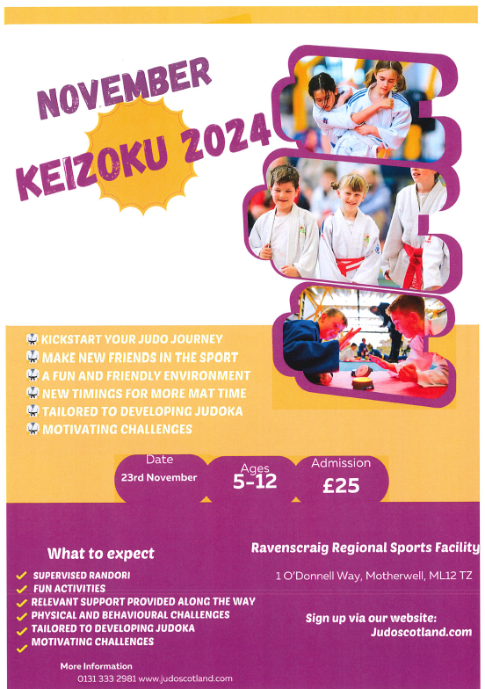

Event Type:

- A developmental event for Judoka with limited event experience, which is age and stage appropriate
Venue:
- Ravenscraig Regional Sports Facility, 1 O’Donnell Way, Motherwell, ML1 2TZ

Dates:
- Saturday 23rd November 2024

Closing Date
- Friday 8th November 12.00 (Noon)
- JudoScotland are trying to provide opportunities for as many members as possible, but the entry may have to close early if the event gets so busy that the event experience may be affected.

Entry Fee:
- £25.00
- Entry can be made via https://www.judoscotland.com/

Age Bands:
- 5, 6,& 7 years
- 8, 9, & 10 years
- 11 & 12 years

Weight Categories:
We are looking to put trust and responsibility to the child’s guardians to weigh and enter your child’s weight correctly.
Spot checks will be done on the day of event.
- Please weigh you’re child at home and enter your child weight in kilograms when you enter online.

Registration Time :
- 5, 6,& 7 years on the day of event: 9.30-9.40am
- 8, 9, & 10 years on the day of event: 11.30-11.40am
- 11 & 12 years on the day of event: 1.30-1.40pm

Format:
- Judoka will be grouped with in their age and weight
- Judoka will be split into groups and allocated a colour and a mat to register at.
- As well as time on the mat, developing their technical judo ability, judoka will also take part in the physical and behavioural challenges in line with JudoScotland Player Development Framework.

  - Pre event judoka (judo player) will be allocated a colour by email with their Registration time to attend at.
  - On the day of event please change into your judo suit before registration at your allocated mat colour.
  - Once changed please head to the allocated colour table to register.
  - Once registered at allocated mat, the judoka will be given a colour sash which represents the allocated mat.
  - All judoka will be guaranteed a designated mat time.
  - Randori time with be 2 minutes per match.
  - A minimum of 4 randori contest, which will be done as a group exercise not individually.
  - In between each randori section a judo specific activity will take place on the judoka allocated mat, so there is no need for players to leave their mat once event has started.
  - Once all randori matches and activities have taken place, children will bow off and be given their exclusive prize bag.

What you need:
- All judoka must have a valid JudoScotland membership
- A Judogi (judo suit) is required for this event.
- A round neck white T-shirt to wear under your judo suit
- Suitable footwear to wear when off the mat.
- A filled water bottle.
- Keep up to date with event information by downloading Telegram.

Reward and Recognition:
- All judoka will receive a certificate and an exclusive prize bag.
- Certificates and prizes will be given out once the group session has been completed.

Photography & Videography:
- Photography and video recording of activities may take place at this event; photographs may also be taken for promotional purposes including publication on websites and social media.
- By entering this event, you indicate your acceptance of these conditions and parents (in the absence of any expressed objection) provide their consent to taking and use of photos/videos.

General:
Using your personal information
- We will use the information provided at time of booking so that we can:
  - Process your entry or booking onto a course, event or competition and communicate with you in relation to your attendance at the event.
  - The full JudoScotland privacy notice can be viewed at: www.judoscotland.com.
  - The decision of the event organiser is final.
  - The event is run in line with JudoScotland/BJA child protection policy.
  - All information supplied will only be used for event organisation purposes.

