**2025–2028 WCPP IJF Grands Prix’s & Grand Slam’s**

**Personal Programme Application Form**

**LA 2028 Cycle**

**Please use this form to apply for Grand Prix’s & Grand Slam’s only.**

To apply for a **CONTINENTAL OPEN / EUROPEAN CUP** please complete the online entry form: [**https://www.britishjudo.org.uk/international-event-entry/**](https://www.britishjudo.org.uk/international-event-entry/)

**Contact Details:**

|  |  |  |  |
| --- | --- | --- | --- |
| Fighter Name: |  | D.O.B / Age: |  |
| Address: |  | | |
| Email: |  | Mobile No.: |  |
| Coach Name: |  | Coach to attend event? (Please circle) | **YES / NO (If yes, your Coach will be registered in Judobase)** |

**Event Details:**

|  |  |  |  |
| --- | --- | --- | --- |
| **Event Name:** |  | **Event Date:** |  |
| **Weight Cat:** |  | **JNR / SNR:** |  |
| **I would like to be coached by a member of the GB Coaching Team (if GB attending):** | | | **YES / NO** |

**Performance Rationale:** (What are your reasons for wishing to attend this event?).

|  |
| --- |
|  |

|  |  |
| --- | --- |
| **CURRENT IJF WORLD RANKING POSITION:** |  |

**2025–2028 Personal Programme Performance Standards:**

*All fighters who wish to attend IJF World Tour Events and EJU Events, must follow the LA2028 Cycle Personal Programme Policy Process & Criteria, and strictly adhere to the set timelines as stated in the policy.*

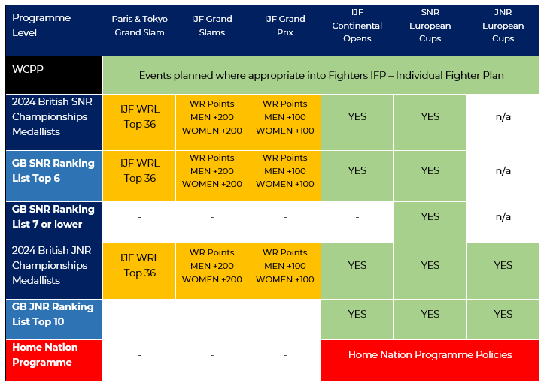

**In Summary:**

GB fighters who medal at the British Senior Championships, can apply to attend

IJF Continental Opens and Senior European Cups;

GB fighters who are ranked in the Top 6 of the GB Senior Ranking List, can apply to attend

IJF Continental Opens and Senior European Cups;

**IJF GRAND PRIX’s;** GB fighters who medal at the British Junior or Senior Championships or are Ranked in the Top 6 of the GB Senior Ranking List, and at the time of application deadline have accumulated, Men +100 WR points and Women +100 WR points, can apply to attend Grand Prix’s;

**IJF GRAND SLAMS;** GB fighters who medal at the British Junior and Senior Championships or are Ranked in the Top 6 of the GB Senior Ranking List, and at the time of application deadline have accumulated, Men +200 WR points and Women +200 WR points, can apply to attend Grand Slams;

GB fighters who are ranked in the Top 36 of the IJF WRL can apply to attend the Paris Grand Slam & Tokyo Grand Slam;

GB fighters who are ranked 7 or below on the GB Senior Ranking List, can apply to attend EJU Senior European Cups;

GB Junior fighters who medal at the British Junior Championships or are Ranked in the Top 10 of the GB Junior Ranking List, can apply to attend IJF Continental Opens, Senior and Junior European Cups;

**INJURED FIGHTERS:**

Fighters who have been injured and missed the British Championships and/or ranked outside of the GB Ranking Standards, can apply for dispensation to attend IJF/EJU Tour Events, by providing a **clear performance rationale** for consideration for the attendance at such event. This should be put in writing providing such details for consideration by the Performance Team. The Performance Team’s decision will be final. Please email [john.bramall@britishjudo.org.uk](mailto:john.bramall@britishjudo.org.uk) to apply for Injury Dispensation.

To apply for a Grand Prix or Grand Slam, please complete this application form in full and send to [john.bramall@britishjudo.org.uk](mailto:john.bramall@britishjudo.org.uk) by the event application deadline date (see separate Event Deadline Dates document), otherwise your application will **NOT** be considered for approval.

***IMPORTANT:*** *Fighters are responsible for ensuring their BJA Membership Licence is in date and for organising their own Travel / Medical Insurance when attending International Events as part of their Personal Programme as the BJA Travel Insurance Policy does* ***NOT*** *cover them.*